CAD Operator Position

There are two TMC Computer Aided Dispatch (CAD) Operators in the Santa Lucia TMC. These operators monitor CAD stations to view and update real-time incident logs.

Computer Aided Dispatch

The CAD allows operators to view log entries, assigned units, tow vehicles, and witnesses for current incidents. Operators may also send and receive messages to other CAD operators.

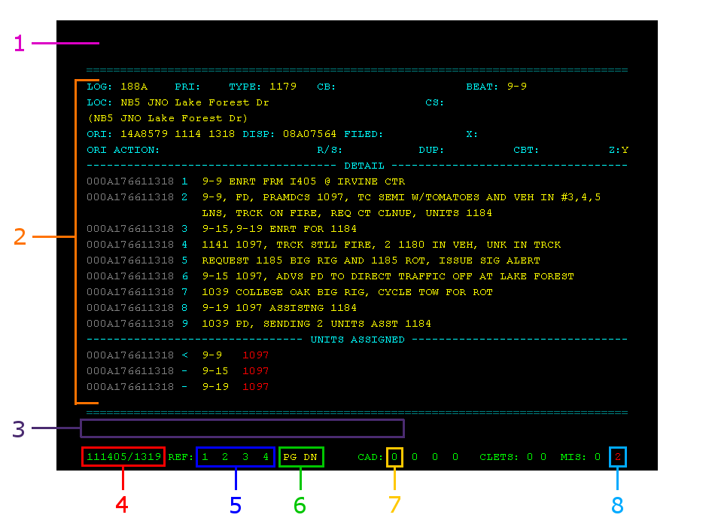

- Command Line – User input.
- CAD Data – CAD output.
- Error Messages – CAD error messages.
- Time/Date – The current date and time. (MMDDYY/hhmm)
- Screen Update – Page update notifications, colored yellow when available.
- Page Scrolling – “PG DN”, “PG UP”, and “UP DN” show possible scrolling.
- Routed Message – Current number of routed messages.
- Screen Number – Current screen number.

CAD Command Summary

Incident Summary – Request an abbreviated list of current incidents.
Syntax: SA.

Incident Inquiry – Request the current log for an incident.
Syntax: II.<log number>

Update Incident – Update an incident by inserting a log entry.
Syntax: UI.<log number>.D/<text> (Update any incident)
UI.D/< text > (Updating incident being viewed)

Route Message – Transmits a routed message to another CAD Operator.
Syntax: TO.<CAD Position(s)>.M/<Message>

CAD Keyboard Commands

Command | Standard Keyboard | CAD Keyboard
Cycle Screen | PG-UP | PAGE SWITCH
Refresh Screen | PG-DN | REFRESH
Page Up | HOME | PAGE SCREEN UP
Page Down | END | PAGE SCREEN DOWN
Transmit Command Line | F1 | CMD LINE XMIT
Next Message | F8 | NEXT QUEUE
Delete Message | F9 | QUEUE DELETE
Previous Message | F10 | PREV QUEUE
Clear Command Line | Shift – F11 | Shift - CMD-LN TERM
Clear Screen | Shift – F12 | Shift - SCREEN TERM

CAD Screen and Page Layout
